**Output Parsers in LangChain**

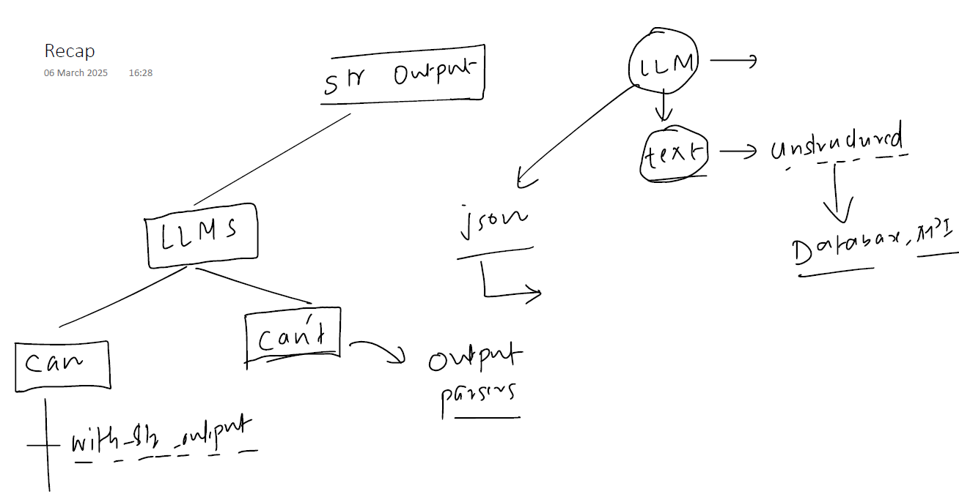

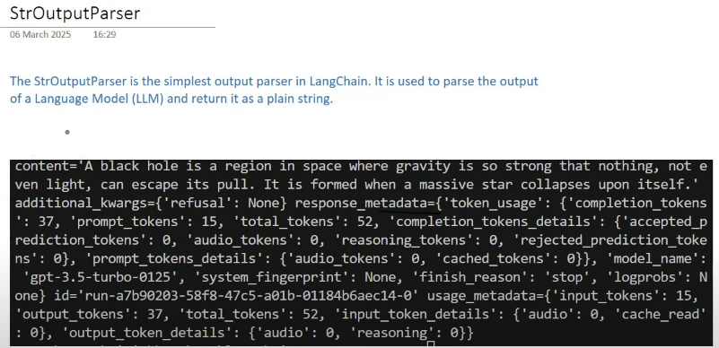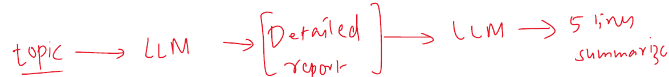

Chains

